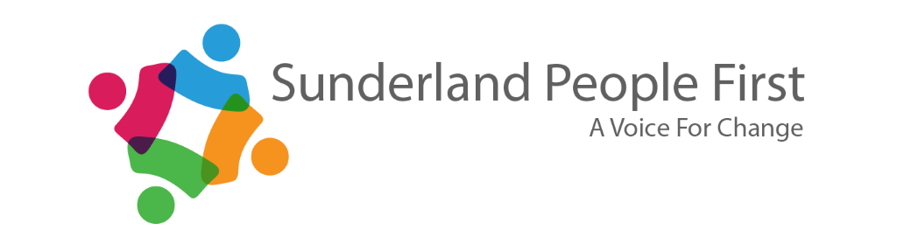

**EASY READ INFORMATION – TERMS AND CONDITIONS**

We provide easy read information for Local Authorities, the NHS and other public bodies.

Our easy read service is produced by experts by experience who have a learning disability or are autistic, to ensure the document is understood by as many people as possible.

Our easy read team has two members of staff who have received training from Photosymbols.

The training involves innovative ways to produce easy read information tailored specifically to the subject matter and its readers.

We use photosymbols images and other images which best reflect the meaning of the text and are not subject to copyright.

Graphics and statistics are difficult to understand for many people with a learning disability. Alternative ways of describing information will be used wherever possible.

Our images and wording are chosen by our advocates. They are proud of their easy read documents and are best placed to choose which words and images they best understand.

We meet Mencap’s standards for easy read information.

This booklet was made by Sunderland People First

This is our standard template for easy read documents.

The customer will be emailed a draft in PDF format. You will be allowed up to 2 sets of changes per document for amendments, so it is important you put all the necessary amendments in your first response.

Slight amendments may be made to the documents, but this will always be checked over by our advocates to ensure they agree.